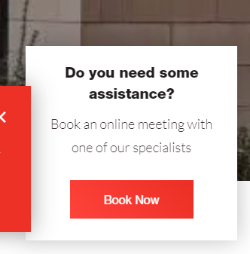
Can we change the wording of the above to read:
Can we help?
Would you like to book an online meeting with one of our sector specialists?

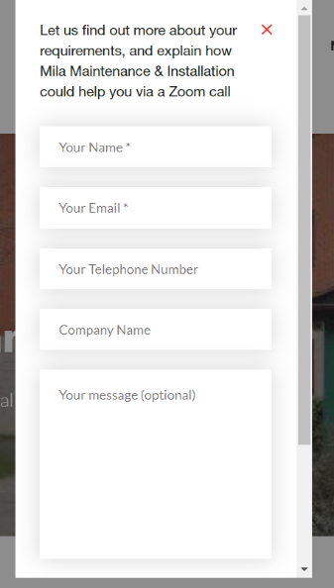
Can we change the wording on the above to read:
Complete the form below and one of our team will be in touch to book an online meeting.
Question
Will the form automatically record the sector that the person filling the form in is interested in?

